
AI CAREER FOR WOMEN
Commerce

Project Title Name
A Project Report
submitted in partial fulfillment of the requirements
of
AICW project

Uyyala Anitha, uyyalaanitha2005@gmail.com
S.alekya, alekyamudhiraj8520@gmail.com
M.Neha, mamillaneha1@gmail.com

Under the Guidance of
Rahul Nawkhare

ACKNOWLEDGEMENT

We would like to take this opportunity to express our deep sense of gratitude to all individuals who helped us directly or indirectly during this thesis work.

Firstly, we would like to thank my supervisor, …………….., for being a great mentor and the best adviser I could ever have. His advice, encouragement and the critics are a source of innovative ideas, inspiration and causes behind the successful completion of this project. The confidence shown in me by him was the biggest source of inspiration for me. It has been a privilege working with him for the last one year. He always helped me during my project and many other aspects related to the program. His talks and lessons not only help in project work and other activities of the program but also make me a good and responsible professional.

……...

…..
……
….
……

ABSTRACT of the Project

The E-Commerce Operations Dashboard project was developed using Power BI to analyze and visualize business performance through interactive dashboards. The project addresses the challenge of monitoring large volumes of e-commerce data, where manual reporting makes it difficult to identify sales trends, customer behavior, inventory status, and profitability.The main objectives of the project are to monitor key performance indicators (KPIs), improve operational efficiency, and support data-driven decision-making. The dashboard analyzes 5,000+ order records, covering 4 product categories, 20+ sub-categories, and 50+ customer locations. Key metrics include Total Sales of $2.30 million, Profit of $286,000, 31,000 units sold, 5,009 total orders, and an overall Return Rate of 5.8%. These metrics help identify top-performing products, high-revenue regions, and customer purchasing patterns.The methodology includes collecting the e-commerce dataset, cleaning and transforming data using Power Query, creating relationships between tables, developing DAX measures for KPI calculations, and designing interactive dashboards using KPI cards, bar charts, line charts, maps, and slicers in Power BI.The dashboard enables users to analyze sales by product category, customer segment, region, and time period. The results indicate improved visibility into business performance, allowing management to optimize inventory planning, enhance marketing strategies, reduce return rates, and increase profitability.In conclusion, the E-Commerce Operations Dashboard transforms raw transactional data into meaningful business insights. The project demonstrates how Power BI can improve operational efficiency, support real-time decision-making, and contribute to sustainable business growth.

TABLE OF CONTENTS
Abstract
List of Figures
List of Tables

Chapter 1. Introduction
1.1 Problem Statement
1.2 Motivation
1.3 Objectives
1.4. Scope of the Project
Chapter 2. Literature Survey
Chapter 3. Proposed Methodology
Chapter 4. Implementation and Results
Chapter 5. Discussion and Conclusion
References

LIST OF FIGURES
Page No.

LIST OF TABLES
Page No.

CHAPTER 1
Introduction
  - Problem Statement: Describe the problem being addressed. Why is this problem significant?

1.1 Problem Statement
In today's competitive e-commerce industry, businesses generate a large amount of transactional data every day. However, analyzing this data manually is time-consuming and often leads to delayed or inaccurate decisions. Organizations face challenges in monitoring sales performance, customer behavior, inventory status, product returns, and profitability from multiple data sources. The absence of a centralized dashboard makes it difficult to identify trends and improve operational efficiency. This project addresses these challenges by developing an interactive Power BI E-Commerce Operations Dashboard that provides real-time insights through visual reports and key performance indicators (KPIs). The dashboard analyzes over 5,000 orders, 31,000 units sold, $2.30 million in sales, and a 5.8% return rate, enabling better business decisions.
1.2 Motivation
The motivation behind this project is to demonstrate how Business Intelligence (BI) tools can transform raw e-commerce data into meaningful insights. Many organizations still depend on spreadsheets and static reports, making performance analysis difficult and time-consuming. By using Power BI, decision-makers can monitor sales, profits, customer trends, product performance, and regional performance through interactive dashboards.
Potential Applications
- Sales performance monitoring
- Inventory and stock management
- Customer behavior analysis
- Product profitability analysis
- Regional sales comparison
- Executive decision support
Impact
- Faster and more accurate decision-making
- Improved operational efficiency
- Better inventory planning
- Increased customer satisfaction
- Higher business profitability through data-driven insights

1.3 Objectives
The main objectives of the project are:
- To develop an interactive E-Commerce Operations Dashboard using Power BI.
- To analyze sales, profit, orders, and revenue using visual analytics.
- To monitor Key Performance Indicators (KPIs) such as Total Sales, Total Orders, Profit, Return Rate, and Customer Segments.
- To identify top-selling products and high-performing regions.
- To analyze customer purchasing behavior and sales trends.
- To support data-driven business decision-making through interactive reports.

1.4 Scope of the Project
The project focuses on designing and implementing an interactive dashboard for analyzing e-commerce operational data using Power BI. It includes data collection, cleaning using Power Query, data modeling, DAX calculations, and dashboard visualization.
Scope
- Sales and revenue analysis
- Profitability analysis
- Product category performance
- Customer segmentation
- Regional sales analysis
- Return rate monitoring
- KPI tracking using interactive visualizations
Limitations
- The dashboard depends on the available historical dataset.
- Real-time data integration is not included.
- Forecasting and predictive analytics are outside the scope of this project.
- Results are limited to the quality and accuracy of the source data

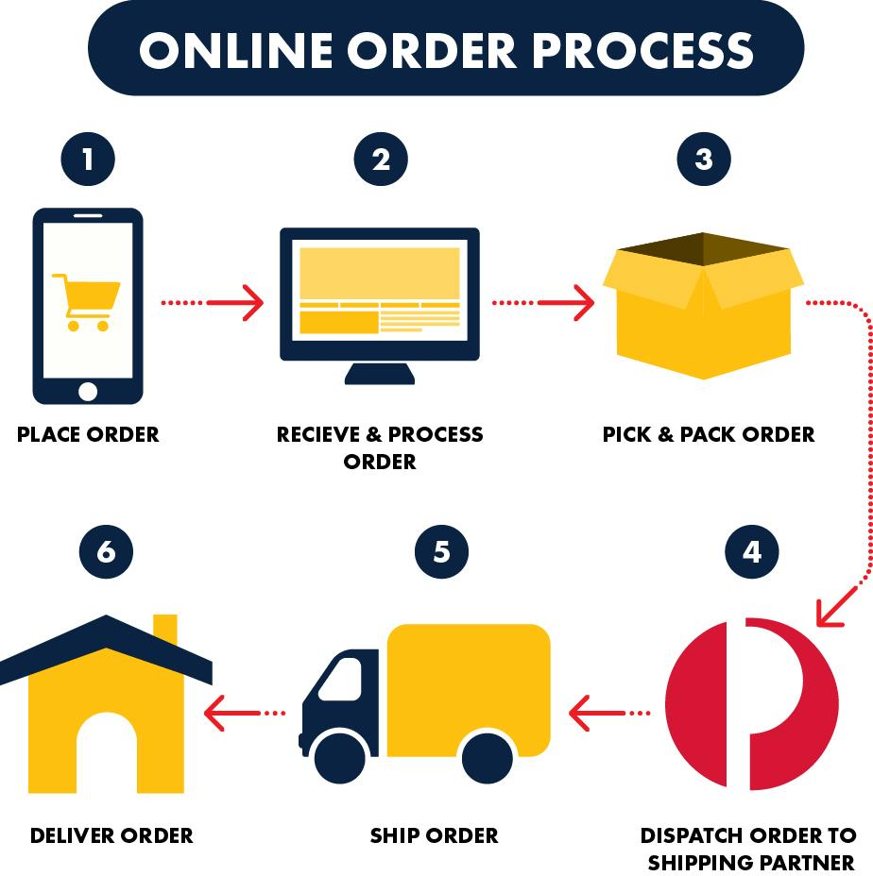

CHAPTER 2
Literature Survey
2.1 The rapid growth of e-commerce has resulted in the generation of large volumes of business data, including sales, customer, product, and order information. Organizations use Business Intelligence (BI) tools to convert this raw data into meaningful insights that support effective decision-making. Interactive dashboards have become one of the most efficient methods for presenting business performance through charts, graphs, and Key Performance Indicators (KPIs).Several studies have highlighted the importance of data visualization in improving business operations. Microsoft Power BI is one of the most widely used Business Intelligence tools because it provides powerful features for data integration, transformation, visualization, and report generation. Previous research indicates that Power BI dashboards help organizations monitor sales performance, analyze customer behavior, track inventory, identify market trends, and improve operational efficiency.Leading e-commerce companies such as Amazon, Flipkart, Shopify, and eBay rely on dashboard-based reporting systems to monitor daily business activities. These dashboards enable business managers to evaluate performance, identify profitable products, monitor customer purchasing patterns, and make faster data-driven decisions. As a result, Business Intelligence has become an essential technology for improving productivity, profitability, and customer satisfaction.
2.2 Existing Models, Techniques, or Methodologies Related to the Problem
The following models and techniques are commonly used in developing an E-Commerce Operations Dashboard:
- Business Intelligence (BI): Converts raw business data into meaningful information for better decision-making.
- Microsoft Power BI: Used for data collection, cleaning, transformation, modeling, visualization, and interactive report creation.
- Power Query: Cleans, transforms, and prepares raw data before analysis.
- Data Modeling: Creates relationships between datasets such as Orders, Customers, Products, and Sales.
- DAX (Data Analysis Expressions): Used to create calculated columns, measures, KPIs, and business calculations.
- Interactive Dashboards: Display data using KPI cards, charts, graphs, slicers, and filters for easy analysis.
- Data Visualization Techniques: Include bar charts, line charts, pie charts, donut charts, maps, and trend analysis to present business information clearly.
These techniques improve reporting accuracy, simplify data analysis, reduce manual effort, and support business decision-making through interactive dashboards.
2.3 Gaps or Limitations in Existing Solutions and How the Project Addresses Them
Many traditional reporting systems rely on spreadsheets and static reports, making business analysis time-consuming and difficult. Existing systems often lack interactive visualizations, centralized reporting, and advanced filtering capabilities. As a result, managers may experience delays in identifying sales trends, customer preferences, and business opportunities.The proposed E-Commerce Operations Dashboard overcomes these limitations by providing an interactive and user-friendly dashboard developed using Microsoft Power BI. The dashboard combines multiple business metrics into a single platform and displays important KPIs such as Total Sales, Total Orders, Total Customers, Average Order Value, Profit, and Return Rate. Users can analyze data by year, quarter, month, region, category, and customer segment using interactive filters and slicers.The project automates report generation, improves reporting accuracy, reduces manual effort, and enables faster, data-driven decision-making. Although the current dashboard focuses on historical data, it provides a strong foundation for future enhancements such as real-time data integration, AI-based sales forecasting, inventory optimization, customer segmentation, and predictive analytics.
Table 2.1 Literature Review Summary
S.No | Author(s) | Year | Title | Technology/Method | Key Findings
1 | Ralph Kimball & Margy Ross | 2013 | The Data Warehouse Toolkit | Data Warehousing | Introduced dimensional modeling for analytical reporting.
2 | Stephen Few | 2013 | Information Dashboard Design | Dashboard Design | Explained effective KPI visualization and dashboard principles.
3 | Microsoft Corporation | 2024 | Microsoft Power BI Documentation | Power BI | Describes Power Query, DAX, data modeling, and visualization features.
4 | Turban, Sharda & Delen | 2022 | Business Intelligence, Analytics, and Data Science | Business Intelligence | Shows how BI supports strategic business decisions.
5 | Imhoff, Galemmo & Geiger | 2003 | Mastering Data Warehouse Design | ETL & Data Warehouse | Discusses integrating business data for reporting and analysis.
CHAPTER 3
Proposed Methodology
  - System Design

3.1 System Design
The E-Commerce Operations Dashboard is designed to collect, process, analyze, and visualize e-commerce business data using Microsoft Power BI. The system imports data from an Excel dataset, performs data cleaning and transformation using Power Query, creates relationships among different tables using Data Modeling, and develops business metrics using DAX (Data Analysis Expressions). The processed data is then displayed through interactive dashboards containing KPI cards, charts, maps, and slicers. The dashboard helps business managers monitor sales, profit, customer behavior, and operational performance efficiently.
    - Registration:
- The first stage of the system is data collection. Historical e-commerce data is collected from Excel files containing sales, orders, customers, products, profits, quantities, regions, and return information. This data acts as the input for dashboard development.

    - Recognition:
- The collected data is cleaned and transformed using Power Query. Relationships are created between different tables using Data Modeling, and DAX measures are used to calculate KPIs such as Total Sales, Total Orders, Profit, Average Order Value, and Return Rate. Finally, the processed data is visualized using Power BI dashboards.

  - Modules Used

3.2.1 Sales Analysis Module
Displays Total Sales, Revenue, Profit, Sales Trend, and Average Order Value using KPI cards and charts.

3.2.2 Customer Analysis Module
Analyzes customer segments, purchasing behavior, and total customers.

3.2.3 Product Analysis Module
Displays top-selling products, category-wise sales, and product profitability.

3.2.4 Regional Analysis Module
Shows sales performance by region using maps and regional charts.

3.2.5 Dashboard Visualization Module
    - Face Detection:
  - Data Flow Diagram
| E-Commerce Dataset |
| (Excel / CSV) |
+----------+-----------+
|
v
+----------------------+
| Data Collection |
+----------+-----------+
|
v
+----------------------+
| Data Cleaning & |
| Transformation |
| (Power Query) |
+----------+-----------+
|
v
+----------------------+
| Data Modeling & DAX |
| KPI Calculations |
+----------+-----------+
|
v
+----------------------+
| Power BI Dashboard |
| (Charts, KPIs, Maps, |
| Slicers & Reports) |
+----------+-----------+
|
v
+----------------------+
| Business Insights & |
| Decision Making |
+----------------------+
    - DFD Level 0
External Entities:
- User/Manager
- Excel Dataset
Main Process:
- E-Commerce Operations Dashboard
Output:
- Interactive Reports
- KPI Dashboard
- Business Insights
    - DFD Level 1 - Student Face Registration Module:
The Data Collection Module is the first stage of the E-Commerce Operations Dashboard. In this module, business data is collected from Excel files containing information such as Order ID, Customer Name, Product Name, Category, Sales, Profit, Quantity, Region, Order Date, and Return Status. The collected data is validated to ensure completeness and accuracy before being imported into Power BI. This module provides the foundation for further data processing and analysis.
Input: Excel Dataset
Process: Import, Validate, and Store Data
Output: Clean and Structured Dataset
    - DFD Level 1 - Student Face Recognition Module:
The Data Processing and Dashboard Module transforms the collected data into meaningful business information. Power Query is used to clean and transform the dataset by removing duplicate records, handling missing values, and formatting data correctly. Data Modeling establishes relationships between different tables, while DAX (Data Analysis Expressions) calculates important KPIs such as Total Sales, Total Orders, Profit, Average Order Value, and Return Rate. The processed data is then displayed through interactive Power BI dashboards.
Input: Clean Dataset
Process: Data Cleaning → Data Modeling → DAX Calculations → Dashboard Creation
Output: Interactive Dashboard and KPI Reports
    - DFD Level 1 - Concentration Analysis Module:
The Business Performance Analysis Module analyzes the processed data to identify trends and patterns in e-commerce operations. The dashboard displays sales performance, customer behavior, regional performance, product profitability, and return analysis using interactive charts, KPI cards, maps, and slicers. Users can filter reports by year, month, region, category,and customer segment to gain detailed business insights. This module supports effective decision-making by providing accurate and easy-to-understand visual reports.
Input: Processed Business Data
Process: KPI Analysis → Trend Analysis → Visualization → Report Generation
Output: Business Insights, Performance Reports, and Decision Support
  - Advantages
- Interactive and user-friendly dashboard.
- Reduces manual reporting effort.
- Provides real-time-style business insights from historical data.
- Tracks KPIs such as Sales, Profit, Orders, and Return Rate.
- Supports faster decision-making.
- Identifies top-selling products and profitable regions.
- Improves business performance monitoring.
- Easy to filter data by year, month, category, region, and customer segment.
  - Requirement Specification
Hardware Requirements:
- Component | - Specification
- Processor | - Intel Core i3 / i5 / AMD Ryzen 3 or above
- RAM | - 4 GB minimum (8 GB recommended)
- Storage | - 100 GB free hard disk space
- Monitor | - 1366 × 768 resolution or higher
- Internet | - Required for Power BI updates and sharing
Software Requirements:
Software | Version
Operating System | Windows 10 / Windows 11
Microsoft Power BI Desktop | Latest Version
Microsoft Excel | Excel 2019 / 2021 / Microsoft 365
Power Query | Built into Power BI
DAX | Built into Power BI
Browser | Google Chrome / Microsoft Edge
File Format | Excel (.xlsx), CSV

CHAPTER 4
Implementation and Result
  - Results of Face Detection
The Sales Analysis module provides a comprehensive overview of the organization's sales performance. The Power BI dashboard displays important Key Performance Indicators (KPIs) such as Total Sales, Total Orders, Total Profit, Revenue, Average Order Value, and Return Rate. Interactive visualizations, including KPI cards, bar charts, line charts, and pie charts, allow users to monitor monthly and yearly sales trends. The dashboard helps identify top-performing products, high-revenue categories, and seasonal sales patterns, enabling management to make informed business decisions.
Result:
The dashboard successfully presents sales performance in an interactive format, making it easy to identify growth trends and areas requiring improvement.
  - Results of Face Recognition
The dashboard visualization module converts processed business data into meaningful graphical reports using Power BI. Data is cleaned using Power Query, relationships are created through Data Modeling, and KPIs are calculated using DAX. The dashboard includes KPI cards, bar charts, line charts, donut charts, maps, and slicers that allow users to filter information by product category, customer segment, region, and time period.
Result:
The interactive dashboard provides accurate, user-friendly reports that simplify business analysis and support faster decision-making.
  - Result Of Concentration Analysis
The Business Performance Analysis module evaluates overall operational performance by analyzing sales, profit, customer behavior, product performance, and regional sales. The dashboard highlights top-selling products, profitable regions, customer purchasing trends, and return rates. Users can apply filters to compare business performance across different periods and categories.
The analysis helps management identify business opportunities, improve inventory planning, optimize marketing strategies, and monitor operational efficiency. The interactive reports reduce manual reporting effort and improve the accuracy of business insights.
Result:
The E-Commerce Operations Dashboard successfully transforms raw transactional data into meaningful business insights, enabling data-driven decision-making and improving overall operational performance.

CHAPTER 5
Discussion and Conclusion
  - Key Findings:
The E-Commerce Operations Dashboard provides a clear analysis of sales, profit, orders, and product performance. The dashboard shows:
- Total Sales: 135K
- Total Profit: 5K
- Total Orders: 730
- Total Quantity Sold: 2K
- Profit Margin: 4%
The dashboard also identifies:
- Electronics generated the highest sales.
- Madhya Pradesh recorded the highest sales among all states.
- Bookcases and Sarees were the top-performing sub-categories.
- Sales varied across different months and years, helping identify business trends.
  - Git Hub Link of the Project: Share the GitHub link
  - Video Recording of Project : The project demonstrate video is not available at the time of thesis submission . The project will be demonstrated during final viva examination.
  - Limitations:
- The dashboard uses a limited sample dataset.
- Real-time data updates are not available.
- Customer behaviour analysis is limited.
- External factors such as market trends and seasonal demand are not included.
- More advanced predictive analytics could improve decision-making.
  - Future Work:
• Integrate real-time sales data.
• Add forecasting using Power BI AI features.
• Include customer segmentation and customer satisfaction analysis.
• Develop mobile-friendly dashboards.
• Improve security with role-based access.
• Add more KPIs and interactive reports.
  - Conclusion: The E-Commerce Operations Dashboard successfully analyzes sales performance, profit, orders, and product categories using Power BI. It helps businesses monitor key performance indicators, identify high-performing products and regions, and make data-driven decisions. The project enhanced skills in data visualization, DAX formulas, dashboard design, and business analytics. Overall, the dashboard is an effective tool for improving business performance and supporting strategic decision-making.

REFERENCES

[1] Microsoft Corporation, Power BI Documentation. Available: https://learn.microsoft.com/power-bi/
[2] Marco Russo and Alberto Ferrari, The Definitive Guide to DAX, 2nd Edition, Microsoft Press, 2019.
[3] Rob Collie and Avichal Singh, Power Pivot and Power BI: The Excel User's Guide to DAX, Power Query, Power BI & Power Pivot in Excel, Holy Macro! Books, 2017.
[4] Microsoft Corporation, Power Query Documentation. Available: https://learn.microsoft.com/power-query/
[5] Han, J., Kamber, M., and Pei, J., Data Mining: Concepts and Techniques, 3rd Edition, Morgan Kaufmann, 2012.
[6] Silberschatz, A., Korth, H. F., and Sudarshan, S., Database System Concepts, 7th Edition, McGraw-Hill Education, 2019.
These references are appropriate for a project on Power BI, Data Visualization, Business Intelligence, and E-Commerce Dashboard Analysis.

Appendices (if applicable)

Appendix A: Dataset Description
The project uses an E-Commerce Sales Dataset stored in Microsoft Excel and imported into Power BI. The dataset contains customer order information used to analyze sales and business performance.
The dataset includes the following fields:
- Order ID
- Order Date
- Customer Name
- State
- Category
- Sub-Category
- Product Name
- Sales
- Profit
- Quantity
- Discount
The data was cleaned and transformed in Power BI before creating the dashboard. It was used to generate KPIs, charts, and reports for analyzing sales, profit, orders, and product performance.

Appendix B: Dashboard KPIs
The dashboard displays the following Key Performance Indicators (KPIs):
KPI | Value
Total Sales | 135K
Total Profit | 5K
Total Orders | 730
Total Quantity | 2K
Profit Margin | 4%
Appendix C: Dashboard Visualizations
The dashboard includes the following visualizations:
- KPI Cards (Total Sales, Profit, Orders, Quantity, Profit Margin)
- Sales by Year and Month (Line Chart)
- Sales and Profit by Category (Column Chart)
- Sales by Category (Donut Chart)
- Sales by State (Bar Chart)
- Sales by Sub-Category (Treemap)

Appendix D: DAX Measures Used
The following DAX measures were created:
Total Sales = SUM(Orders[Sales])

Total Profit = SUM(Orders[Profit])

Total Orders = COUNT(Orders[Order ID])

Total Quantity = SUM(Orders[Quantity])

Profit Margin = DIVIDE([Total Profit],[Total Sales],0)
Appendix E: Tools and Technologies
- Microsoft Power BI Desktop
- Microsoft Excel
- DAX (Data Analysis Expressions)
- Power Query
- Data Visualization Techniques
Appendix F: Business Insights
- Total Sales reached 135K.
- Total Profit was 5K.
- Electronics generated the highest sales.
- Madhya Pradesh recorded the highest sales among all states.
- Bookcases and Sarees were the best-performing sub-categories.
- The dashboard enables quick analysis of sales performance and business trends.

Appendix G: Dashboard Screenshot
Include the screenshot of your final Power BI dashboard here.

